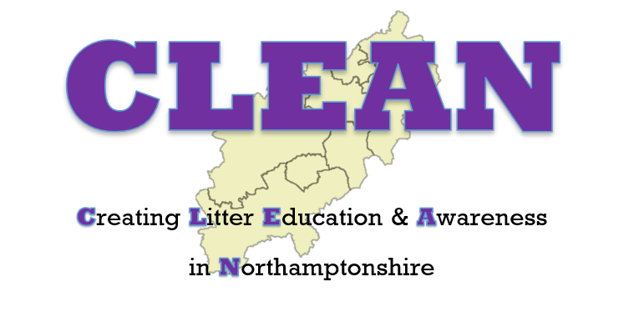

C.L.E.A.N. Presentation Feedback Form
School Name | The Good Shepherd Catholic Primary School
Date of Presentation | 06/01/2023

Y/N
Did you feel the children were engaged by the presentation? | y
Did you feel the material and content was age appropriate? | y
Were the presenters friendly and inclusive? | Very
Did the presentation help enhance your school’s Eco curriculum? | Yes
Would you recommend the CLEAN presentation to partner schools and others in your area? | Yes

Teachers’ Comments:
Teachers found the content great for both KS1 & KS2. Children actively wanted to get working with the community and in the school.

Children’s Comments:
Thank you for this mornings assembly. Im writing on behalf of the Good Shepherd Junior Leadership Team. We are very keen to be involved with the litter wombles and were wondering if it would be possible for us to join you in litter picking around our local area.
We look forward form hearing from you

Yours sincerely
Bendeguz and Janelle
JLT leaders

Please identify one pledge of positive action that your school will undertake over the next 12 months following the C.L.E.A.N. presentation:

