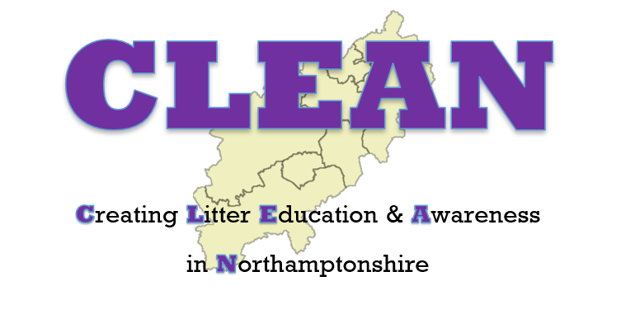

C.L.E.A.N. Presentation Feedback Form
School Name | St Luke’s CE Primary
Date of Presentation | 16.1.22

Y/N
Did you feel the children were engaged by the presentation? | Y
Did you feel the material and content was age appropriate? | Y
Were the presenters friendly and inclusive? | Y
Did the presentation help enhance your school’s Eco curriculum? | Y
Would you recommend the CLEAN presentation to partner schools and others in your area? | Y

Teachers’ Comments:
A brilliant presentation in both of our assemblies. The children were all engaged. It was great to hear all of this information from the experts!

Children’s Comments:
“We learnt that plastic lasts longer than we keep it for”
“We learnt that litter takes a very long time to decompose”
“It was very engaging and interesting”
“It was really nice to learn all the information about littering”
“It was fun and all the kids liked it!”
“We were all shocked about how long things take to decompose”

Please identify one pledge of positive action that your school will undertake over the next 12 months following the C.L.E.A.N. presentation:

We will introduce our litter ambassadors into school.

